Teacher Resources for the North Bay Science Discovery Day: October 26, 2019
Thank you for helping us in our mission to get kids excited about science, technology, engineering, and math (STEM).

Enclosed are 30 North Bay Science Discovery Day (NBSDD) flyers for your students. Please encourage them to take them home and involve their families by attending this FREE event at the Sonoma County Fairgrounds on Saturday, October 26, from 10:00 am to 4:00 pm.

We have provided the form below to maximize the benefit to you and your students. It will encourage students to visit more than one type of exhibit so that they will experience (and get excited about) more than one type of science. The four categories are those of the Next Generation Science Standards Performance Expectations. If you join us at the NBSDD, you may find some great ideas and activities to use in your own classroom.

To find other great STEM activities, go to: northbayscience.org or bayareascience.org

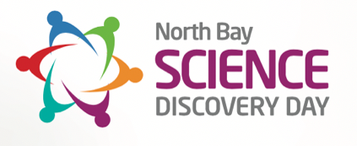
Take the Challenge! Be a Science Explorer!

Student name: ____________________________________________Class: _________________________________

The North Bay Science Discovery Day has booths showing many kinds of science.
Your Science Explorer Challenge is to visit different kinds of booths to see what you can learn.
In the spaces below, record what you asked, learned, or found interesting.

Visit a booth about chemistry or physics. Booth visited: _________________________________________________

Visit a booth about the oceans, the earth (geology), astronomy or weather. Booth visited: ______________________

Visit a booth about plants or animals. Booth visited: ____________________________________________________

Visit an engineering, technology or robotics booth. Booth visited: _________________________________________

To learn more about fun and interesting science events and opportunities, go to: NorthBayScience.org

